Using Participant Stories to Understand Consumers:
A story about a new and simple way to research consumer preferences

By Madelyn Blair, Ph.D. and Molly Catron

October 2004

National Storytelling Network (NSN) SIO SIG

Story provides a simple way to gather insight into consumer preferences at the emotional level.

Abstract
With competition at its highest, wise companies are seeking to understand their customers. One such company is LGE, a Korean manufacturer of home appliances and electronic components, who wished to better understand their American market. They asked NSN to partner with them through the SIO SIGto collect stories about experiences with their products and those of their competitors. Unlike the traditional survey, the stories provided the facts in an emotional context and gave the company a glimpse into the American home. This paper will present the approach taken to provide these stories, the advantages of using story for this type of work, the lessons learned, and a bit of the story itself, just as it happened.

Using Participant Stories to Understand Consumers: A story about a new and simple way to research consumer preferences

It was April 2004 in an auditorium of the Smithsonian Institute and the fourth annual event devoted to storytelling in organizations. In the audience was a woman from the Korean manufacturing company, LGE. We’ll call her Soon Hoon. Listening to the various speakers inspired Soon Hoon, and when she had the opportunity, she introduced herself to Karen Dietz, Executive Director of National Storytelling Network (NSN), a participant at the event, and asked how she might use storytelling in her desire to better understand the American market. And so began a story of its own on how storytellers were invited to participate in a story gathering exercise to explore how Americans think about their appliances – what they look for, what is important, and what they ignore in their purchase decisions.

Introduction
This paper will present in detail how the project was designed and implemented. It will present the steps used to introduce the details of participation, help volunteers to meet the objectives and rules of the project, and keep the momentum going to meet the target date for completion – all in a virtual environment.

The lessons learned from such a project will also be presented. From the lessons of what worked well to what worked less well and including what should be avoided. Overall, the project was a success when it delivered to LGE the agreed deliverables including 94 stories. Lastly, this paper will include some of the feedback received from the company. Whenever possible, we will enhance the information with some of the story of this project as well.

Purpose of the project
The purpose of this project was to provide LGE with insights into the American consumer through the use of story.

After meeting the representative of LGE at a conference in Washington, DC and hearing of the company’s interest in their customer’s perspective, Karen Dietz, the Executive Director of NSN, began a conversation about using the membership of NSN to write stories of their experience with LGE and its competitors’ products. The final agreement involved the collection and interpretation of approximately 100 stories written by the membership of NSN.

NSN is an association of more than 3000 members located throughout the US with some members from Canada and a small but growing contingent from other countries around the globe. Using the NSN membership assured that the stories would represent many socio-economic groups in the US, and so, give a representative mix of American households and their buying habits and preferences. Moreover, these were people who had an abiding interest in storytelling, many of them being storytellers themselves.

LGE named five product lines to be examined in this project: cellular phones, refrigerators, televisions, washing machines and microwaves.

At the completion of the project, LGE would receive 100 stories, the first 50 about the various LGE products with matching stories about competitors’ products for the second 50. In addition, an analysis of the common threads and insights gained through the stories, and an Über-story that would capture the essence of all of the stories into one. LGE also asked that a profile of the participant group be submitted. No names were to be attached to any of the stories.

Methodology
LGE, a Korean manufacturing company, specified that the “purpose of this project is to listen to the real people’s stories about how they think about LGE products, and what are their unexpressed satisfaction or desires regarding electronic goods they use or they want to use. The electronic goods could range from domestic appliances, entertainment devices like TV and stereo, or communication devices as mobile phones.”

The Storytelling in Organizations Special Interest Group (SIO SIG) was challenged to design and manage the collection of the stories from the members and the resulting interpretation and summary of the results. The analysis of the stories would provide a study of the common threads across the stories and result in a consumer analysis for the LGE management team.

Understanding the power of stories to provide facts in the emotional context, the research team planned to review the stories in each category looking not only for product problems within each category but also for the future desires of the consumers relative to each product. This information would not only provide LGE with information about problems with their current products but would provide some idea of what the consumers would like to see in future product lines. Once stories were gathered, the remaining content analysis would be fairly straightforward.

The greatest challenge was to entice 50 people to do their own research on the products and write up their stories – all while following the rules of the study. From invitation to analysis and reporting, the work had to be done in six weeks. Starting in May, the project was to be completed by mid June.

Phase I: Laying out the ground rules and invitation
Madelyn Blair agreed to lead the project with the assistance of Molly Catron, as part of the research team. They were joined during the design phase by Karen Dietz to assure that the design would satisfy the contractual agreement which Dietz had negotiated.

One of the first challenges facing the team was to define some ground rules for the project. Spreading the invitation across the NSN community would provide the opportunity for a large group of storytellers to participate and would give LGE a broad sampling of their consumer market. Based on experience, the team knew business leaders would need short, descriptive stories to meet their needs. The leaders needed to be able to “see” the consumer living out the experience with their products or the competitor’s product.

The team decided that the stories needed to be written in pairs and by the same person. Thus, if Harry wrote a story about an LGE cell phone, he was to write a companion story about a competitive cell phone, e.g., Motorola. The stories were to be limited to one page or 500 words each. Shorter stories were acceptable. For each pair of stories, the storywriter would receive an honorarium of $100. Before beginning, however, the person had to register the product line they wished to write about.

Each story was to describe an actual PAIN situation (a hassle, a frustration, disappointment, performance failure) and/or a GAIN situation (a satisfactory feature or experience or a desired need for the future.) The tellers were encouraged to include the facts along with the emotions experienced in each incident but not to put the stories into some other context, like a myth or fairy tale.

An open invitation was sent from NSN’s office to all NSN members to participate in the study. Included in this invitation were links to the rules and requirements of the study and a sample story. The contact point for all further communication, a special email address set up for the project, was named in the invitation as well. See Attachment 1 for the actual text of the invitation letter.

The groundrules for participation
Each individual was asked to test out two products – one that is the LGE brand and another that is manufactured by a competitor. The story was to reflect the experience they or another member of their family had while using the product in the store.
The participants were limited to two stories – one about an LG product, one about a competitor’s.
They were asked to select the product line of interest to them before collecting the story.
The stories were to be sent electronically to Madelyn Blair (at a special email account set up for this).
All stories were to be accompanied by certain demographic information and a release form.
LGE (through NSN) paid $100 to each storyteller for the two stories.
All entries submitted and accepted were to be used by LGE for internal market research only. No stories were to be used in LGE’s advertising or promotional literature (as stipulated in our contract with them). All accepted stories would be submitted to LGE anonymously so your privacy would be protected (as stipulated in our contract with them).
Demographic data would not be attached to any stories but submitted to LGE as a separate report (as stipulated in our contract with them).

The concept was that once a product was selected, the storyteller would locate an LGE product either in actual use or at the store or showroom. The storyteller would then spend time either using or exploring the product. Once they had satisfied themselves they understood the product sufficiently to make a purchase decision if they were to purchase it, they would write the story. (No purchase was necessary.) This process was replicated for the competitors’ product.

Phase II: Administering the collection of stories
Madelyn Blair had conducted many surveys before. When she was approached by the SIG, she didn’t hesitate to say that she would do it. The basics had been laid out, the number of respondents wasn’t that large, and she worked with virtual groups all the time. Her experience was with businesses, and when the emails began coming in to her, she could see there was a real difference here. Storytellers seem to write different kinds of emails. They were chatty and full of little details. They were sometimes ambiguous, but they were always fun to read.

As time went on, her return emails became more and more chatty. Participants who were having problems doing what they committed to do felt at ease to tell her their problems. Time and again, a person who felt they weren’t going to make it, sent in a great pair of stories. Participants, who didn’t think they could do another pair but thought they wanted to, did exactly that. The usual task of prodding respondents became one of just listening and encouraging. Storytellers did seem to be different.

The administration of the story collection process was handled entirely by the SIO SIG team. The special email address was set up in Yahoo to assure simplicity and least cost. Each day the address was checked and responses sent the same day. If the email included a question, the question was answered or clarified as soon as possible. If the email was a submission, an individualized thank you email was sent immediately. In the meantime, each new participant and their email address was recorded in an electronic journal to keep track of who was participating, what product line they were writing about, whether the stories had been received, and if the required demographic information and release forms had been received.

What came out of this continuous checking of emails was a surprising result. With some of the participants, the communication was encouraging but straightforward. With others, the individualized responses in turn came back as personal notes to the coordinator. As a result, several electronic relationships began. While this was not a part of the design but rather an outcome, it became part of what kept the task of follow up a welcome one. (Sample emails can be seen in Box: Sample emails from storytellers.

As time went by, two things became clear. First was that among the 3000 NSN members, only 25 had said they would participate. There was a shortfall of 25 storytellers. Second, the selection of product line took time that was needed for the participants to do their research. Remember the entire time frame was to be six weeks – start to finish. In addition, it was found that the NSN web site where the additional information on ground rules was published was inaccessible. A technical glitch had occurred. The design had been too constrained for the time frame given.

Sample emails from storytellers

“I emailed an hour ago but forgot to give my demographics. I prefer cell phones but also feel very attached to washing machines.”
“Among the rules is also the demographic request. I wasn't going to respond because I'm in the Ozarks rather than a metropolitan area. But a second call came. The request is for marketing ...
I don't want to slam LGE, but being miles 150 from Springfield, MO, 90 from Jonesborough, AR, 50 from Mt. Home, AR - one is apt to shop the Internet. (At least that is thee promoted program and people are known to make a living from E-bay.) And today gasoline is approaching 1.90 +.
I went Internet on LGE and found neither sites for shopping on line or within cities. If I can't find one of their products at my local Super Wal-Mart down the road 10 miles to compare to a competitors, I feel that at least I have answered LGE's question as to how to reach the American market better "nicely" with my story.
Now as I lay myself down to rest, I will think of how I might write a story or two. Bluntly, I have found being a new elder single in a "we" community is not comfortable... I hope to sell and be out of here for the coastal NW. Besides, AR is not a storytelling Tellebration state. Peace. Smile.
I'm thinking.”

Rapid calls to NSN solved the technical problem. The other two problems were more difficult. The number of NSN participants was significantly low, and a second invitation was sent out. Moreover, the rules were altered to allow the same storyteller to write on more than one product line so long as they did two stories for each, and the target date was extended another week. Lastly, it was agreed that non-NSN members could participate so long as they had interest in the use of story. The invitation list was expanded to members of local storytelling in organizations groups around the country.

This seemed to solve the problem. Commitment to write stories grew to the requisite number, and stories began to come in. There seemed to be little difficulty in writing the 500 words. Blair, as she read each, felt that some would have gone on more if the limit had been expanded. With only two exceptions, the stories that came in were acceptable as sent. In the case of the two, a carefully worded email was sent to them asking for the stories to be rewritten with the rules in mind. In both cases, the stories came back just fine.

Two challenges existed during this phase. The first was just keeping up with the email traffic, responding to every one that came in with appropriate response, encouragement, and appreciation. The second challenge was keeping track of the detailed demographic information and assuring the release forms were received (via hard copy regular mail). To keep the project moving forward at top speed, this work took a minimum of 2 hours a day, 7 days a week for the four weeks of data collection. Again, the friendly notes from participants made the time a pleasure – by and large.

On-going communication example
I hope we are able to meet some day. I have really enjoyed your stories and our conversation. I agree that writing a second story on how easy it is to purchase another brand via the Internet or Wal-Mart sounds like real information for the company. So, please, write it up.
Many, many thanks.
Madelyn
PS I discovered the great North West about 3 years ago. It is fantastic country.

Phase III: Analysis

The next challenge facing the team was to read each of the stories looking for the possible themes surfacing around a particular product or the perception of LGE as a company. This process involved the reading and rereading of each story while making a list of key words or concepts in each story. After comparing notes the following themes were identified:

Product Location and Sales Personnel:
The search for LG products has many paths. Generally, sales people don't know the products, and the exceptional sales person who did, stands out. There were many stories of this ilk. Mostly, the stories were about going to several locations before finding an LG models on the shelves. Salespeople did not always know the products and did things like offer to let the person see the ‘box’ it came in.

Internet:
Internet searching is used a great deal to understand the product options, etc. This is clearly becoming the first step in searching for new purchases. When the information is lacking (dimensions of an appliance, for example), the customer simply moved on until they had this information.

Product Features:
Features that make life easier, more pleasant, more beautiful, more functional are looked for. These varied depending on the age, sex, life style of the person. But each person mentioned features as deciding criteria. One in particular was the TV remote. If designed poorly, the product was discarded from consideration.

Pricing:
Price came into play from some, but it was rarely the only deciding factor.

Consumer Values
There was a strong link to personal life values – cleanliness, efficiency, time savings, reliability, appearance, beauty, age related values and needs, etc.

Controls
Customers want to see the machine in action. Impossible to do with a washing machine, but considered important for other appliances – from Tvs to microwaves. Especially the controls in action were important. Several mentioned the importance of clearly understandable labels on buttons and features.

Technology
American customers have a certain fascination with technology itself. The stories reflect an attraction to striking functions that are new or interesting. The degree of interest in any given “bell or whistle” seemed to be dependent on age and lifestyle.

Instructions for Use
Many cited that they did not like to read through manuals. Appliances with instructions built in were noted as valuable.

View into the Customer’s Life
Many storytellers talked about how they use the appliances giving insight into another level. The stories provide a unique opportunity to look at a “day in the life” of a customer.

Cleaning
The ability to keep an appliance clean was mentioned a few times.

Knowledge of LG Products
There were several surprised customers when they learned about LG products. The product line was new to many consumers. Without knowing the company, some wondered about the reliability. The customers learn to trust companies they know.

Relationship with Appliances
There are amazing relationships between people and their appliances. A manufacturer should never assume the appliance is only for function. Many compared several brands when shopping but did not demonstrate a great deal of brand loyalty in the actual selection of the product.

Product | Areas of Primary Interest
Microwaves | Operational Ease, Appearence
Washing Machines | Front vs Top Loading, Environmental Issues
Refrigerators | Cleaning, Shelving Features
TVs | New Technology, Price
Cell Phones | Recharging, Reception, Ease of Use

Results
*Participants and their stories

Thirty-one storytellers ranging in age from 24 to 74 years of age contributed stories. They represented twenty-two states and the British Columbia. The stories were delightful to read and provided insight into the consumers lifestyle. Some featured colorful dialogue with sales personnel:

When I told him I wanted an LG TV – he looked at me with a funny expression and then said, “Well, we have these Zenith monitors. They are made by LG.” They were way out of my price range - $1,500 and up. “No, these don’t work for me.” I said explaining I really needed something less expensive. I asked again about the LG and he said “Where did you get this idea you want an LG TV?” Well, I felt a bit awkward – given that I didn’t want to tell him I was doing market research, and yet I had never even heard of the LG name brand until I got the notice requesting volunteers to do market research. “I just heard they were an interesting company,” I reply. “Oh,” he presses on – aware there is something I’m not telling him. “You know I’ve been working in the business for twenty years, and no one has ever asked me for an LG TV.” “Oh, is that right? Well, that’s very interesting,” I reply with a mysterious grin. “I think that I’ve just gotten what I needed.”

Other stories featured a glimpse into the comsumer’s routine as it revolved around the product:

Whenever I open the refrigerator door at home, our block of cheese in the side door catapults and sometimes lands on my bare feet. I grew up in Wisconsin and having cheese fall to the ground like that seems as great as a taboo as when the American flag touches the ground. The LG model solved this problem by having a dairy corner with a revolving case so I would have less bruises on my feet.

Some stories pointed out some interesting differences in perception in writing users manuals:

Well, OK...if you promise not to tell, I also detest reading the operation manuals and trying to understand what they say. It is not uncommon that many of the manuals’ communication devices and software I’ve used are difficult to understand. When reading them and trying to apply their directions, frequently, things are explained in a way I simply cannot relate to. Either odd terms are used or steps, which to others may seem obvious, are left out. I’m old! I’m slower than others! I’m that impatient person who panics that she is getting old and can’t comprehend what comes naturally to others. And, you know what....she blames others for inability to understand. I will always take the easy route...when someone explains things in easy terms, without the “mumbo, jumbo” sales tactics. Give me “simple” and I’ll give you my business. I’m just an aging lady who doesn’t like to change.

There were 94 stories in the end. We didn’t quite make the 100, but we were close enough. We had abandoned any hope of controlling what people would research so that we would have an equal number of stories in each category. It was much better to let folks write about what they were interested in from the start. It also made the process go much faster without the person losing a day or two waiting for ‘approval.’ In the end, the distribution of stories across the categories of products was sufficient to give a profile for each one. (Microwaves were most popular, 12+ people choosing to write about them.)

Sample Story: Zen of Laundry by Lindan Johnson
It was the chrome… the gleaming round circles of silver chrome that enchanted me and convinced me that it was perfectly reasonable to spend $2,300 for a washer and dryer.
These were not appliances. These were works of Art—which meant I’d have to budget for another $300 for the pedestals to properly display my LG 2277 stainless steel drum sculptures.
Keep in mind- this magic all occurred after seeing a small ad in the Sunday supplement. On Monday I decided that as much as I loved the chrome and the beautiful domestic objects d’artes, I needed to do more research on the machines and consider what my actual laundry needs would be now.
So there I stood, clutching my king-sized black cotton (washable) bedspread in the appliance section of Best Buy. The Hotpoint washer and dryer came with the house when I bought it six years ago. I hated the look and feel of them and suffered with their smallness. Even though there was only me at home most of the time, I wanted the ability to be able to wash anything.
And I wanted a beautiful washer and dryer.
Unfortunately, the salesman did not understand the art, the spirituality or the consumer side of laundry. He was young—I wondered if he had ever even washed clothes or if his mom still did his laundry. I put my bedspread in the washer (several people gathered to watch the show) and he shook his head and said, “Ummmm you do know that you can’t actually do your laundry here—the machines aren’t hooked up?” And I asked him why it was that you can see all the television sets working, use the computers, test drive a car and yet can’t see how a washer and dryer works before you buy it and have it in your house. He didn’t know.
I asked the salesman about some of the negative things I’d heard about LG machines- why does the heater only run during the rinse and not the actual wash cycle; does the tilt of the drum make it more difficult to balance because quite a few people seem to think the machines are loud and noisy; is there a preferred soap recommended with the machine because other people had complained that the laundry smelled strange after the wash?
He didn’t have the answers. It would have been nice if he did. I already had gathered a great deal of information from different sources on the Internet. I’ve been considering my purchase for at least six months now. I’m sure if they would have had a sale where they included the pedestals for free with the purchase of the washer and dryer that I would have immediately gone for it. And I was disappointed that the latest edition of Consumer Reports has still not rated LG.
Then I remembered the sleek retro laundry look and how they’d make my laundry room sparkle. And I remembered a comment from one woman who said her teenage son’s white sock absolutely sparkled when they came out of her 2277.

The only thing I love more than chrome is a sparkly white sock.

From the company’s perspective, the project exceeded their expectations. They immediately applied the findings to the marketing of their products in the US. In their own words, “Given the time limit, I say the result was more than satisfactory.”

What we learned
We learned lots of lessons doing this project. Aside for the lessons we will apply in all future studies was a totally unexpected one. NSN members didn’t believe the invitation was real. One of the common questions that came in at the beginning of the project was whether the offer of money for the stories was real. Was the team just teasing people? When we responded that this was true, some individuals still refused to believe the offer and did not participate. Some of those who decided to participate anyway were surprised when they actually received payment. Perhaps, this was part of the reason that more members did not participate. Hopefully, this won’t be a problem in the future – at least with NSN members.

Aside from this totally unexpected lesson, several others were learned from the doing of the project. Besides the obvious lesson of making sure that your web site works before you send out the announcement and keeping it up to date – here are the major lessons we learned from this project.
Lesson 1: use story as a data gathering medium.
Using story to capture how an individual responds to a product is remarkably illuminating. Stories capture the details; they capture the feeling and emotion of the moment; they allow a glimpse into another’s thinking. Focus groups are often used in marketing to determine how consumers react. A story about the product within a context provides a rich source of insight. We think it can be richer than the focus group setting can provide. For one thing, the context of each story is different, thus providing impressions from different settings as well as different people. Lesson one: use story as a data gathering medium.
Lesson 2: Storytellers know how to write stories that capture more of the emotion and context.
The idea of using NSN members was done to assure that the stories would come from people from many walks of life. It was also believed that with their natural interest in storytelling, they would know what makes a good story. The stories from those who are storytellers themselves were distinctive in creating a picture of the situation in the story.
Lesson 3: Select the rules carefully.
Fewer rules make for a more efficient project. Time spent to answer questions about rules, assuring that individuals have followed the rules – it all takes time. Make certain that each rule really adds to the final result. For example, the early rule that participants could select a product only if there were ‘slots’ left for it didn’t really add to the final results as the categories were all of interest to participants – it was only a matter of degree. In fact, allowing true self-selection gave more information about the products. The rule was eliminated during the project.
Lesson 4: Don’t shy away from working virtually.
Of the 46 participants, perhaps 10% were known to the project team. This did not get in the way of developing good working relationships with every participant. It required quick (daily) response to emails, acknowledgement of and response to personal comments, and a gracious style in answering all. These are easily done. Those running the research must understand the human element of the project. Only by recognizing this and responding at the human level will virtual work be effective.
Lesson 5: Limit the length of the story.
A limit to the size of the story forces clear thinking and presentation of the most relevant information. There are reasons why it takes time to learn how to write a good story. One of them is learning how to select what is needed from what is part of the whole story. The size limits helped storywriters to do this.
Lesson 6: Lead time is important to assure good participation, but keep the time limit for participation short but reasonable.
In July, Molly Catron presented the results of the project at the pre-conference meeting of the Storytelling in Organizations Special Interest Group. The group was enthusiastic about the opportunity the project provided for storytellers and for the application of storytelling in the business world. They believed the project represented the recognition of story as a powerful vehicle to provide factual information. The tacit knowledge held within the stories gave LGE a glimpse into American consumers and their life styles. But no one from the SIG signed up.

When we decided to do this project, we believed that every one of the members of the SIO SIG would participate just because it was an example of using story to meet organizational needs. In the end, aside from the team, no one did. We couldn’t understand this until the pre-conference when we asked why so few storytellers of the SIG participated in the project. Many said they could not meet the deadline requirements due to other commitments. Others said they were taken back by the offer and not accustomed to having the opportunity to use their stories in this fashion. Most applauded the project as a good way to demonstrate the talents of the storytellers and to showcase storytelling as a powerful knowledge management tool.

Although it was clear that the lead time on this project was a bit too short, we also realized that if the lead time had been too long, the interest in doing the work would wane. Participants were given about 2 weeks to decide on the product, do the research, and write the stories. We had to extend the time in order to allow participants the time they needed to make the necessary arrangements to view the products as well as write. A three to four week window would be better lead time.
Lesson 7: Use a dedicated email address.
The original intention of using a single, dedicated email address was done to keep the tasks of managing the project separate from other work being done. Blair receives over 200 emails a day normally, and to add the project to that level of mail would have confused her work and taken longer to deal with effectively. However, in the end, the strategy of a dedicated email address should be used all the time. It made it enormously easy to manage the project. Although not important in this project due to the fact that all email was handled by Blair, a single email account would allow a team to manage such a project if a team is called for, for example, due to the number of participants. It would require a certain level of coordination among the team members, but it would allow access to all while maintaining simplicity for the participants.

Conclusions
Using storytellers to tell the stories of their experiences with products is a powerful strategy for quickly gathering perceptions about products at several levels – intellectual, emotional, and situational. The stories revealed how and where the participants experienced the products, researched the products, and made decisions about the products. A company looking for such insights learns the features that led to perceptions and decision. But it also learns where and what information to provide to aid in researching the product. It learns in what context the decision is most likely to be made. It learns who is involved in the decision. All these perspectives come from the same source – the story.

Leading a large story-collection process requires a person or team who begins with the human element of the storytellers and maintains communication that builds on this human quality. It means that the person or team must be willing to both be organized (to keep things straight and consistent) and willing to communicate at the human level. Even when done virtually, this kind of project requires time – both of the team and for the participants to arrange their own research and writing of the stories. Cutting the time too short limits breadth of response. Ground rules must be simple and easy to understand from the start and place as few limits on the self-selection and style of the storytellers.

Companies commissioning this type of project can expect something new. Numbers become less important than the strong and more complex messages that come from such an approach. Using storytellers to tell their product related stories is an effective strategy that should be used again.

About the Authors

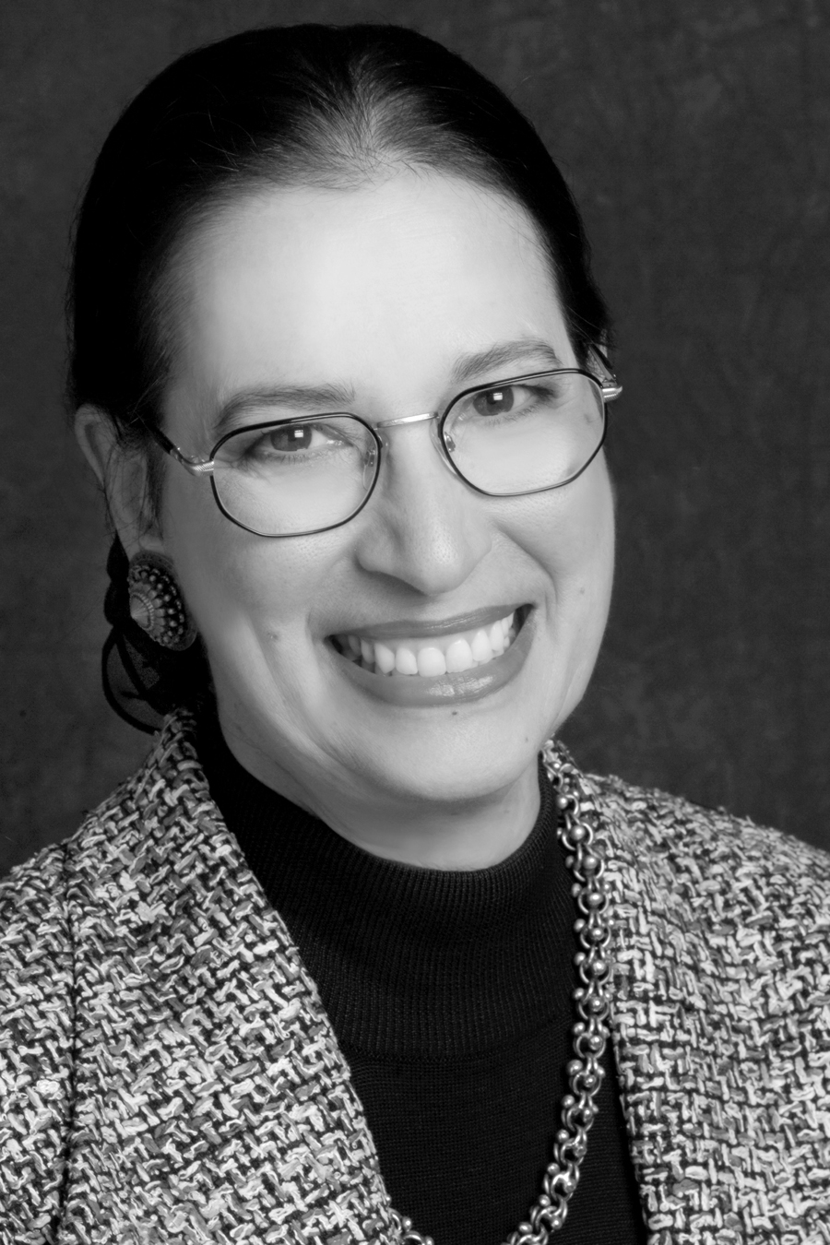  mblair@pelerei.com | Madelyn Blair, Ph.D.  Pelerei, Inc.  www.Pelerei.com  The stories of our lives contain within them the truth through which we live. - Madelyn Blair
Dr. Madelyn Blair is the president of Pelerei, a recognized leader in complex analytical studies, organizational development, knowledge management, and leadership development. Pelerei, Inc., is a firm dedicated to helping clients turn vision into reality. From individual advice to building knowledge sharing groups to corporate strategic planning, she brings out the best in her audience. She has used story consciously in every aspect of her work for the past ten years. Madelyn is one of the founding members of Goldenfleece, the story-in-organization group in DC. She is partnered with The Center for Narrative Studies, offering programs in Narrative Practice. Named an Associate of the Taos institute, her work includes applying appreciative inquiry to enhance effectiveness and helping clients create strong, energized work groups. She is currently leading an international project to reinvigorate the UN through the use of story. Dr. Blair received her doctorate in organizational psychology from the University of Tilburg, The Netherlands. She writes extensively and is a regular conference speaker.

Molly W. Catron
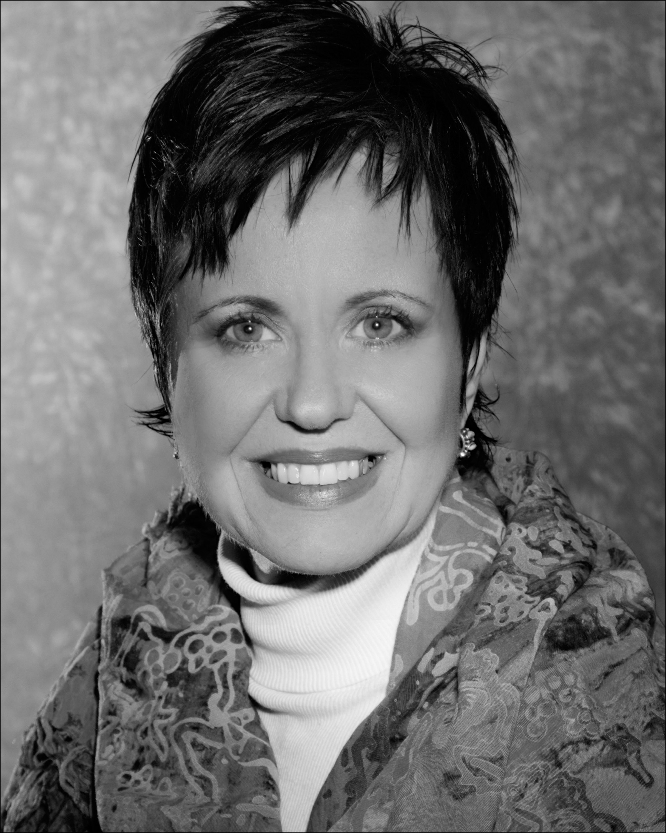
Storyteller and Workshop Guide

www.mollycatron.com

The body carries us. The mind teaches us.
The heart warms us. The spirit inspires us.
When they are united, we are passionate, joyful and committed. Stories can take us there. –Molly Catron

Molly Catron is a storyteller with twenty years experience in Corporate America. As an organizational development consultant, she studied various aspects of organizational behavior. She believes many of the problems in organizations and relationships are based on the inability to connect as human beings. Molly has used story for leadership development, change management, corporate strategy development, root cause analysis, market research and other areas to help organizations be effective in the Information Age. Molly will receive a Masters Degree in Storytelling from East Tennessee State University in December 2004. In addition to performing story, she is also interested in developing an understanding of the dynamic of story in communication in order to put this powerful form of communication back into its rightful place in the human culture. She is particularly drawn to gathering and crafting stories that teach, transform and inspire others. She is a member of the National Storytelling Network, the Storytelling in Organizations SIG, The Storyteller Association, the Network of Biblical Storytellers, and is a performing member of the Jonesborough Storytellers Guild.
ATTACHMENT 1: The invitation
Dear NSN Member,

50 Storytellers Needed! The SIO SIG and NSN have recently been offered the possibility of using our storytelling experience in creating stories for the LGE Company in Korea.

LGE, a Korean electronics company, wishes to understand better the American market, and it has offered to pay people to tell stories about their products. They have asked NSN to partner with them in the collection of these stories.

The Project:
They are asking that an individual test out two products – one that is the LGE brand and another that is manufactured by a competitor. They ask that the story be real and reflect the experience you or another member of your family had while using the product in the store. There are a few rules about which products they are interested in having you test. These are all contained in the attached ‘LGE Story Collection Project: Story Criteria.’

The Details:
Madelyn Blair, SIO SIG and NSN member is the point person for this project.

Here are the details you need to know before saying yes.
- You are limited to two stories – one about an LG product, one about a competitor’s.
- You must select the product line you are interested in before collecting the story and send the choice to Madelyn Blair: pelerei@mac.com. You may be asked to choose another product line depending on the distribution of the stories collected. The choice needs to be received by May 10.
- The stories are limited to 500 words and must be received by May 15.
- The stories are to be sent electronically to Madelyn Blair: pelerei@mac.com.
- All stories must be accompanied by certain demographic information (see the “Story Criteria” sheet).
- A release form must be signed by anyone in the story for each story. This is to be sent to Madelyn Blair, 2379 Broad Run Ct. Jefferson, MD 21755.
- LGE (through NSN) will pay $100 to each storyteller for the two stories.
- All entries submitted and accepted will be used by LGE for internal market research only. No story will be used in LGE’s advertising or promotional literature (as stipulated in our contract with them).
- All accepted stories will be submitted to LGE anonymously so your privacy will be protected (as stipulated in our contract with them).
- Demographic data will not be attached to any stories but submitted to LGE as a separate report (as stipulated in our contract with them).

This is a new opportunity for NSN to show what can be done through story. I hope you will consider this and send your selection in quickly. The time frame is short, but that should make it all the more fun.

Sincerely,

Storytelling in Organizations (SIO) Special Interest Group (SIG). Special interest groups are organizational structures that NSN uses to allow those who wish to focus their discussions on the use of story to meet others who share the same focus.

